Wireshark Lab 1: IP

Group Details:
Rushab Roihan 1003945289
Jasper

Mark:

 | Question | Answer
1 | Select the first ICMP Echo Request message sent by your computer, and expand the Internet Protocol part of the packet in the packet details window.  What is the IP address of your computer? | 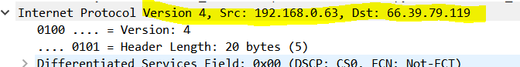  IP address: 192.168.0.63
2 | Within the IP packet header, what is the value in the upper layer protocol field? | ICMP (1)  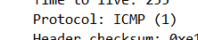
3 | How many bytes are in the IP header? How many bytes are in the payload of the IP datagram? Explain how you determined the number of payload bytes. | 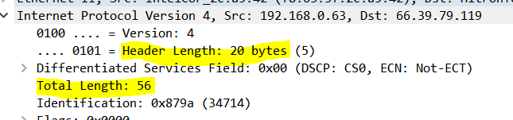  Header Bytes: 20  Payload Bytes: 36 (Total length = 56, Header byte = 20 -> 56-20=36)
4 | Has this IP datagram been fragmented? Explain how you determined whether or not the datagram has been fragmented. | IP datagram has not been fragmented yet because we did not see any IPv4 fragments. It will fragment when we transmit longer ICMP echo requests. The more fragment=0 so therefore the data is not fragmented
5 | 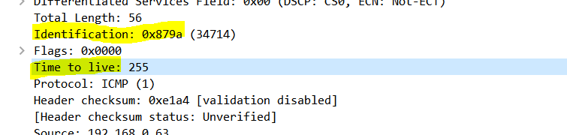  Which fields in the IP datagram always change from one datagram to the next  within this series of ICMP messages sent by your computer? | Identification field is incrementing  Time to live is also incrementing
6 | Which fields stay constant? Which of the fields must stay constant? Which fields must change? Why? | 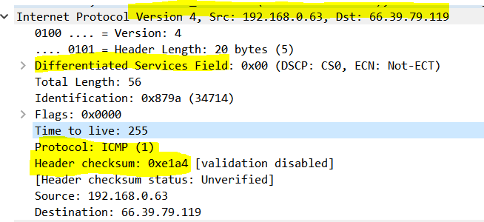  The fields that stay constant:  - Version(IPv4 always used)  - Header Length(Does not change since we using ICMP packet)  - Source IP(IP address my computer does not change)  - Destination IP (We are always sending to the same destination)  - Upper layer Protocol(Same protocol each time)  - Differentiated Service (Same protocol every time)  The fields that must remain constant:  - Version(IPv4 always used)  - Header Length(Does not change since we using ICMP packet)  - Source IP(IP address my computer does not change)  - Destination IP (We are always sending to the same destination)  - Upper layer Protocol(Same protocol each time)  - Differentiated Service (Same protocol every time)  The fields that change:  - Identification field(Since each IP datagram has different ID)  - Time to live(Since that is how trace route works  - Header checksum(since header changes, checksum must change)
7 | Describe the pattern you see in the values in the Identification field of the IP datagram | Yes, they are incrementing with each ICMP Echo request  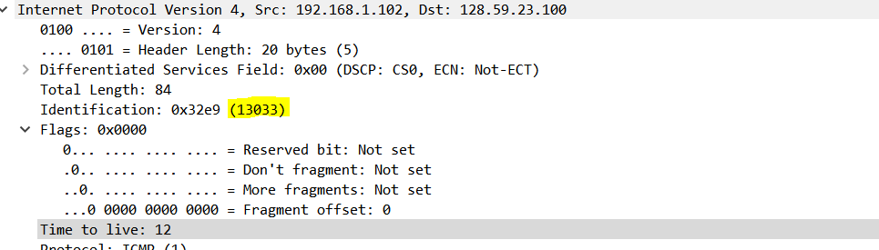  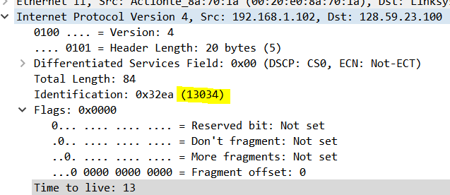
8 | What is the value in the Identification field and the TTL field? | 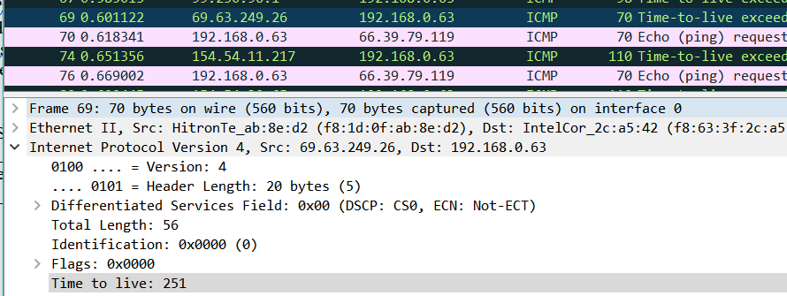  Identification field: 0x0000  TTL field: 251
9 | Do these values remain unchanged for all of the ICMP TTL-exceeded replies sent to your computer by the nearest (first hop) router? Why? | The identification field changes for all the ICMP TTL-exceed replies since the identification field is a unique value. When two or more IP data have the same identification value it means they are fragmented. TTL field remains unchanged since the TTL for the for router is always the same.
10 | Find the first ICMP Echo Request message that was sent by your computer after you changed the Packet Size in pingplotter to be 2000. Has that message been fragmented across more than one IP datagram? | 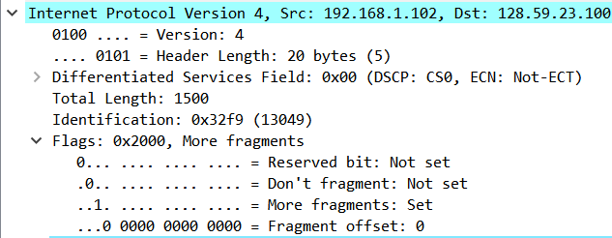  Yes, this packet has been fragmented across more than one IP datagram
11 | Print out the first fragment of the fragmented IP datagram. What information in the IP header indicates that the datagram been fragmented? What information in the IP header indicates whether this is the first fragment versus a latter fragment?  How long is this IP datagram? | 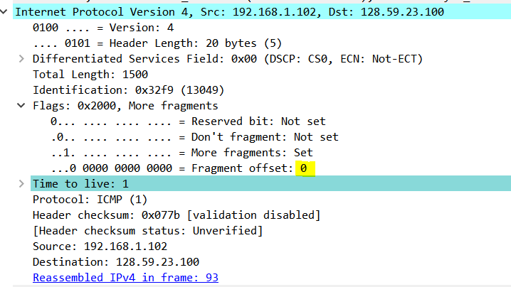  The flags bit shows how the datagram has been fragmented. Since the fragment offset is 0, we know it is the first fragment. The first datagram has a total length of 1500 including the header.
12 | Print out the second fragment of the fragmented IP datagram. What information in the IP header indicates that this is not the first datagram fragment? Are the more  fragments? How can you tell? | 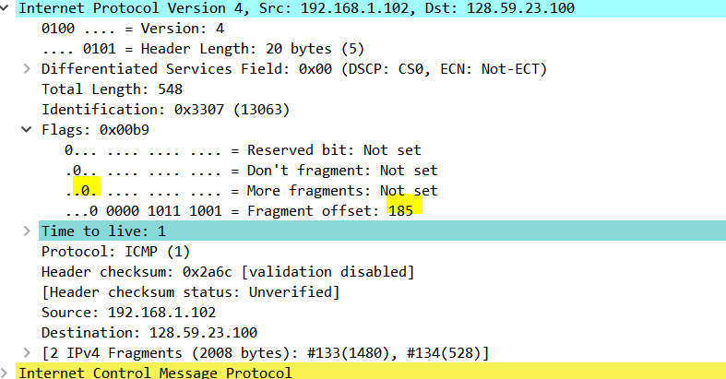  We can tell that this is not the first fragment because it has an offset of 185. It is the last fragment since the more fragment flag is 0.
13 | What fields change in the IP header between the first and second fragment? | The fields that changed are :  - Total length  - Flags  - Fragment offset  - Checksum  *Look at Q12 and Q11 to see these changes
14 | How many fragments were created from the original datagram? | There are 3 packets that are created from the original datagram
15 | What fields change in the IP header among the fragments? | The IP header field that changed between all the fragments are :  - Fragment offset  - Checksum  Between the first two packets and the last packet, we see a change in total length and also in the flag. The first two packet have a total length of 1500, with a more fragment set to 1 and the last packet has a total length of 568 with the more fragment set to 0.  